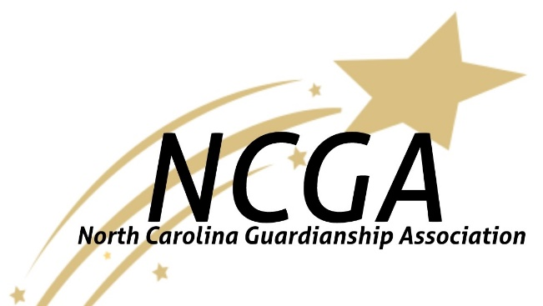

Virtual Fall Forum

The Guardianship Dilemma:

Balancing Autonomy and Safety

September 17, 2021 9am-4pm

Program

8:45am Link Opens

9am Welcome (House Keeping: Online Etiquette, Educational Credit, Certificates of Attendance, etc.)

9:15am The Guardianship Dilemma: Balancing Autonomy and Safety

Mark Gott. Esq.
The presenter will be talking about the statutory responsibility of the guardian to balance autonomy with safety, the pros, and cons of limited guardianship, when limited guardianships work and when and why they sometimes don’t work so well. He will also be looking at some case studies that show the need to balance autonomy with safety.

10:45am Break

11am Booze, Sex, and Money

Jonathan Martinis, Esq.

We all make decisions, every day. Good ones, bad ones, silly and significant. Our choices make us who we are and show us who we want to be. Making decisions doesn’t just feel good, it’s good for us. Study after study shows that people with disabilities who make more choices - who are more self-determined - have better lives. Too often, people with disabilities lose their right to make choices through guardianship. This presentation will talk about the importance of choice and how self-determination can lead to better life outcomes. We’ll discuss an alternative to guardianship called Supported Decision-Making and ways that it can empower people with disabilities to work with their friends, family members, and professionals to make their own choices and direct their own lives without a guardian.

12:15pm Lunch Break

1:00 pm Guardianship, Options/Alternatives, and Restorations

Jean Farmer Butterfield
This session shall supply an overview of guardianship, options/alternatives to Guardianship, and restoration of rights. The presenter will provide a list of options/alternatives to seriously consider prior to any guardianship being put in place and afterwards, discuss the proceedings for guardianship, and for restoration to competency. Questions, comments, and recommendations will be discussed at the end of the presentation.

2:15pm Break

2:30pm Long Term Care Placements, Thoughts, and Considerations

Tracy Warner, MSW
The presenter will give an overview of the Long-Term Care Ombudsman Program. The presenter will take a deep dive into a discussion pertaining to Residents’ Rights in Long-term Care Facilities and how the rights of residents in long-term care facilities intersects with guardianship. The presenter will discuss ways in which Long-Term Care Ombudsman and guardian representatives can collaborate to better serve residents in Long-Term Care Facilities. The presenter will open the discussion for questions, suggestions, and recommendations for opportunities to partner together to uphold and protect the rights of residents in Long-Term Care Facilities.

4pm Closing and Educational Credit Directions

Fees and Educational Units

The North Carolina Guardianship Association is offering this Virtual Fall Forum Free of Charge to the general attender. Should you require verification of attendance a small fee will be requested to cover administrative costs. The process to verify attendance throughout the Forum will be discussed in the Welcome at 9am.

Each participant, whether in need of attendance verification or not is required to register on the North Carolina Guardianship Association website (nc-guardian.org) to receive the link. When possible, we ask that you watch the Forum in small groups, respecting all Covid-19 precautions. The number of attendees is limited, and we want to make sure everyone who wants to participate can do so.

Speaker Bios

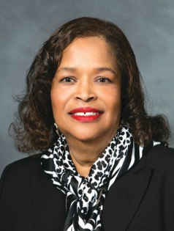 | Jean Farmer-Butterfield  jfarmerbutterfiled@arcnc.org  Jean Farmer-Butterfield has been a long-time advocate and legislative champion for individuals with disabilities. She has worked as a consultant and manager of non-profits in the health and human services field for many, many years. Recently Jean retired from the ARC of NC where she served as the Director of LIFEguardianship and the NC House of Representatives where she served for over 17 years as a legislator. In 2020, Governor Roy Cooper
nominated Farmer-Butterfield to the state Employment Security Board of Review, and her appointment was confirmed by the NC legislature.
Jean has been an advocate for NC guardianship reform for years and has presented on a variety of subjects including Alternatives to Guardianship. Jean is a founding member of the NC Guardianship Association and is currently serving as the President Elect for the NC Guardianship Association Board of Directors.

Mark D. Gott

mgott@hnftlaw.com

Mark D. Gott is an attorney from Charlotte, NC. A significant portion of Mark’s practice deals with matters associated with elder abuse. Mark began his legal career an Assistant Clerk for the Mecklenburg County Superior Court where he presided as a Hearing Officer over incompetency proceedings as well as other probate matters. Building on the experience he gained in the Clerk’s

office and in private practice, Mark is a sought-after presenter for continuing education courses for attorneys and is active in educating the public about guardianship and other legal issues.

Jonathan Martinis
jgmartin@syr.edu

Jonathan Martinis is Senior Director for Law and Policy with the Burton Blatt Institute (BBI) at Syracuse University. He leads BBI’s national and international efforts to ensure that older adults and people with disabilities receive appropriate supports and services, including Supported Decision-Making, to lead inclusive, independent, and self-determined lives.
In 2013, Martinis represented Jenny Hatch in the nationally acclaimed "Justice for Jenny" case, helping Ms. Hatch secure her right to live where and how she wants, to make her own decisions, and direct her own life. Jenny’s case was the first trial to hold that a person with disabilities has a right to engage in “Supported-Decision Making,” – rather than be subjected to an unnecessary permanent, plenary, or full guardianship.

Since the Hatch legal decision, Jonathan has presented to and trained thousands of individuals, families, advocates, attorney, professionals, and service providers about everyone’s Right to Make Choices and direct their own lives, while receiving the services and supports they need to do so.
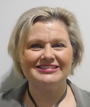 | Tracy Warner  twarner@ptrc.org  Tracy Warner has worked and served in Health and Human Services her entire professional career. She started as a team member of one of the original Assertive Community Treatment Teams in NC and then moved on to provide Case Management Services to individuals with severe and persistent
mental illnesses. From Case Management Tracy moved into an Olmstead and Hospital Liaison position, meeting with individuals at a State Psychiatric Hospital and their homes. When Mental Health Reform took place in the early and mid-2000s, Tracy continued her work as an advocate at the local LME/MCO as a Consumer Affairs Specialist. Today Tracy uses her knowledge and skills and is an Ombudsman in the Long-Term Care.

